**GENERAL INTEGRATED SCIENCE– UNIT 1**

**TASK 7 – Ecology & Natures Cycles Test**

**NAME: _____________________________________ WEIGHTING: 5%**

**DATE: _______________________________________ MARK: ______ /40 =**

**Multiple Choice Questions** (7 marks)

1. Which of the following is NOT an abiotic factor?
2. Decomposer
3. Wind
4. Humidity
5. Temperature
6. Identify the possible link “A” in the following food chain: Plant 🡪Insect 🡪 Frog 🡪 A🡪 Eagle
7. Cobra
8. Parrot
9. Rabbit
10. Wolf
11. When water droplets are large enough, to fall from the clouds, it is called
12. Condensation
13. Transpiration
14. Sublimation
15. Precipitation
16. In the carbon cycle, both terrestrial and aquatic organisms exchange _________ with the atmosphere.
17. Carbon monoxide
18. Oxygen gas
19. Carbon dioxide
20. Methane (CH4)
21. Compared to the amount of carbon on Earth 20,000 years ago, there is currently:
22. Much more carbon on Earth because it evaporates from the ocean as temperatures rise
23. Much less carbon on Earth because of increased farming
24. Exactly the same amount of carbon on Earth
25. Twice as much carbon on Earth because of burning fossil fuels
26. Biodiversity refers to the variety and variability of life on Earth. Biodiversity is typically NOT a measure of variation at which level
27. Genetic
28. Ecosystem
29. Species
30. Gender
31. The ecological relationship between a hawk and a rabbit is the same type of relationship as that between
    1. a tick and a deer.
    2. a frog and an insect.
    3. a mouse and a chipmunk.
    4. a bee and a flowering plant.

**Short Answer Questions (33 marks)**

1. Define ‘ecosystem’. (1 mark)

________________________________________________________________________________________ ________________________________________________________________________________________

1. The following question refers to the image below.
2. State what type of ecosystem is presented in this image. (1 mark)

________________________________________________________________________________________

1. Describe two features of this type of ecosystem that enabled you to make your decision for ‘part a’.

(2 marks)

________________________________________________________________________________________

________________________________________________________________________________________ ________________________________________________________________________________________

________________________________________________________________________________________

1. If the environment suddenly changed, explain whether a generalist or a specialist would be more likely to survive. (2 marks)

________________________________________________________________________________________

________________________________________________________________________________________ ________________________________________________________________________________________

1. 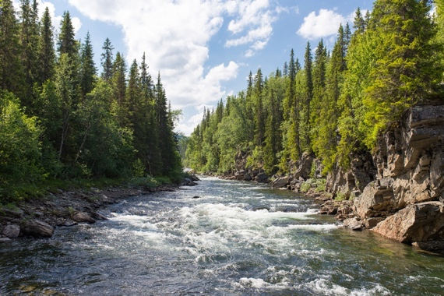On the image on the right, label a part of the: (4 marks)
   1. atmosphere
   2. hydrosphere
   3. lithosphere
   4. biosphere
2. 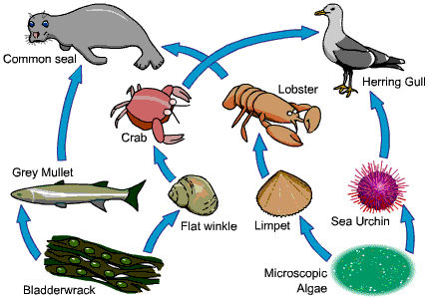Below is a diagram of the food web of a marine ecosystem.
3. Draw a food chain from this food web. (1 mark)

___________________ 🡪 ___________________ 🡪 ____________________ 🡪 __________________

1. Using this food web, write the name of a: (3 mark)

|  |  |
| --- | --- |
| **Herbivore** |  |
| **Producer** |  |
| **Apex Predator** |  |

1. State what the arrows in a food chain represent. (1 mark)

________________________________________________________________________________________________________________________________________________________________________________

1. Describe the role of decomposers in a food chain. (2 marks)

________________________________________________________________________________________

________________________________________________________________________________________ ________________________________________________________________________________________

1. A disease has wiped out most of the flat winkle population; explain what will happen to the numbers of: (3 marks)

|  |  |
| --- | --- |
| **Grey Mullet** |  |
| **Crab** |  |
| **Lobster** |  |

1. Describe why a predator-prey relationship between a lion and a gazelle is not symbiotic.

(1 marks)

________________________________________________________________________________________

________________________________________________________________________________________



1. Observe the graph above. Explain which ecological interaction most likely exists between Species A and B.

(3 marks)

________________________________________________________________________________________

________________________________________________________________________________________ ________________________________________________________________________________________ ________________________________________________________________________________________

________________________________________________________________________________________ ________________________________________________________________________________________

1. Describe the difference between evaporation and transpiration in the water cycle. (2 marks)

________________________________________________________________________________________

________________________________________________________________________________________ ________________________________________________________________________________________ ________________________________________________________________________________________

1. 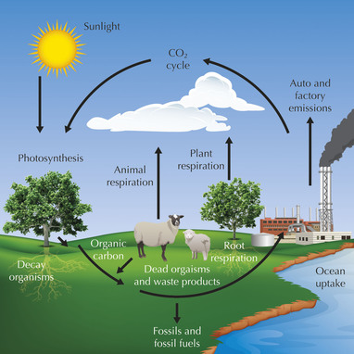Use the image of the carbon cycle below to answer the following questions.
2. What is the one carbon storage place on Earth? (1 mark)

________________________________________________________________________________________

1. Explain the relationship between forests and atmospheric carbon dioxide levels. (2 marks)

________________________________________________________________________________________

________________________________________________________________________________________ ________________________________________________________________________________________________________________________________________________________________________________

1. State two ways that humans use carbon in everyday life (2 marks)

________________________________________________________________________________________________________________________________________________________________________________

________________________________________________________________________________________

1. Describe one way that humans are impacting the carbon cycle (2 marks)

________________________________________________________________________________________________________________________________________________________________________________

________________________________________________________________________________________ ________________________________________________________________________________________

**End Test**